Clickhouse Installation - Standalone
Step-1: Update the system
sudo dnf update -y
sudo dnf install -y curl tar

Step-2: Detect Architecture
uname -m
Then set:
case $(uname -m) in
x86_64) ARCH=amd64 ;;
aarch64) ARCH=arm64 ;;
*) echo "Unsupported architecture"; exit 1 ;;
esac
export ARCH

Step-3: Get Latest Version
Command:
LATEST_VERSION=$(curl -s https://raw.githubusercontent.com/ClickHouse/ClickHouse/master/utils/list-versions/version_date.tsv | \
grep -Eo '[0-9]+\.[0-9]+\.[0-9]+\.[0-9]+' | sort -V -r | head -n 1)
export LATEST_VERSION
echo $LATEST_VERSION

Step-4: Download tarballs for each Clickhouse component
Command:
for PKG in clickhouse-common-static clickhouse-common-static-dbg clickhouse-server clickhouse-client clickhouse-keeper
do
curl -fO "https://packages.clickhouse.com/tgz/stable/$PKG-$LATEST_VERSION-${ARCH}.tgz" \
|| curl -fO "https://packages.clickhouse.com/tgz/stable/$PKG-$LATEST_VERSION.tgz"
Done

Step-5: Extract and install packages
Components:
- clickhouse-common-static
Command:
# Extract and install clickhouse-common-static package
tar -xzvf "clickhouse-common-static-$LATEST_VERSION-${ARCH}.tgz" \
|| tar -xzvf "clickhouse-common-static-$LATEST_VERSION.tgz"
sudo "clickhouse-common-static-$LATEST_VERSION/install/doinst.sh"

- clickhouse-common-static-dbg
Command:
# Extract and install debug symbols package
tar -xzvf "clickhouse-common-static-dbg-$LATEST_VERSION-${ARCH}.tgz" \
|| tar -xzvf "clickhouse-common-static-dbg-$LATEST_VERSION.tgz"
sudo "clickhouse-common-static-dbg-$LATEST_VERSION/install/doinst.sh"

- clickhouse-server
Command:
# Extract and install server package with configuration
tar -xzvf "clickhouse-server-$LATEST_VERSION-${ARCH}.tgz" \
|| tar -xzvf "clickhouse-server-$LATEST_VERSION.tgz"
sudo "clickhouse-server-$LATEST_VERSION/install/doinst.sh" configure
sudo /etc/init.d/clickhouse-server start # Start the server

- clickhouse-client
Command:
# Extract and install client package
tar -xzvf "clickhouse-client-$LATEST_VERSION-${ARCH}.tgz" \
|| tar -xzvf "clickhouse-client-$LATEST_VERSION.tgz"
sudo "clickhouse-client-$LATEST_VERSION/install/doinst.sh"

Step-6: Start ClickHouse
sudo systemctl start clickhouse-server
sudo systemctl enable clickhouse-server
Check status:
sudo systemctl status clickhouse-server

Step-7: Verify Installation
clickhouse-client
Inside client:
SELECT version();
If it returns version → success

Step-8: Set password for default user
Edit:
sudo nano /etc/clickhouse-server/users.xml
Find <default> user and set:
<password>password</password>
Restart:
sudo systemctl restart clickhouse-server

Step-9: Allow Remote Connections (since SigNoz is on another VM)
Edit:
sudo nano /etc/clickhouse-server/config.xml
Find:
<listen_host>::</listen_host>
If not present, add:
<listen_host>0.0.0.0</listen_host>
Restart:
sudo systemctl restart clickhouse-server
It should result like:

Step-10: Add Security Group Inbound Rule in AWS
EC2 → Security Groups → Inbound Rules → Edit inbound rules
Add a new rule:
Rule for ClickHouse
Field | Value
Type | Custom TCP
Port | 9000
Source | 0.0.0.0/0 (Not Recommended for production)
Description | SigNoz access

Step-11: Connectivity Test
nc -zv <CLICKHOUSE_PRIVATE_IP> 9000 [From another machine]
Also Check clickhouse-client,
sudo dnf config-manager --add-repo https://packages.clickhouse.com/rpm/clickhouse.repo

sudo dnf install -y clickhouse-client
clickhouse-client --version

clickhouse-client --host <ClickHouse_VM_Public_IP> --port 9000 --user default --password

Result: It should get succeeded in another dummy VM.
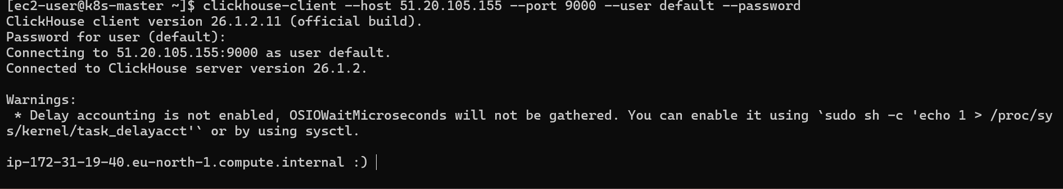

Zookeeper (in same Clickhouse VM)
Step-1: Install Java
sudo dnf update -y
sudo dnf install -y java-17-amazon-corretto-headless
Check installation: java -version
Step-2: Download and extract Zookeeper
curl -L https://dlcdn.apache.org/zookeeper/zookeeper-3.8.5/apache-zookeeper-3.8.5-bin.tar.gz -o zookeeper.tar.gz
tar -xzf zookeeper.tar.gz
Step-3: Create the necessary zookeeper directories and copy
sudo mkdir -p /opt/zookeeper
sudo mkdir -p /var/lib/zookeeper
sudo mkdir -p /var/log/zookeeper
sudo cp -r apache-zookeeper-3.8.5-bin/* /opt/zookeeper
Step-4: Create Zookeeper config
sudo bash -c 'cat <<EOF > /opt/zookeeper/conf/zoo.cfg
tickTime=2000
dataDir=/var/lib/zookeeper
clientPort=2181
admin.serverPort=3181
EOF'
Step-5: Create the zookeeper systemd environment file
sudo bash -c 'cat <<EOF > /opt/zookeeper/conf/zoo.env
ZOO_LOG_DIR=/var/log/zookeeper
EOF'

Step-6: Create zookeeper user & set permissions
sudo getent passwd zookeeper >/dev/null || sudo useradd --system --home /opt/zookeeper --no-create-home --user-group --shell /sbin/nologin zookeeper
sudo chown -R zookeeper:zookeeper /opt/zookeeper
sudo chown -R zookeeper:zookeeper /var/lib/zookeeper
sudo chown -R zookeeper:zookeeper /var/log/zookeeper
Step-7: Create the zookeeper systemd service
sudo bash -c 'cat <<EOF > /etc/systemd/system/zookeeper.service
[Unit]
Description=Zookeeper
Documentation=http://zookeeper.apache.org

[Service]
EnvironmentFile=/opt/zookeeper/conf/zoo.env
Type=forking
WorkingDirectory=/opt/zookeeper
User=zookeeper
Group=zookeeper
ExecStart=/opt/zookeeper/bin/zkServer.sh start /opt/zookeeper/conf/zoo.cfg
ExecStop=/opt/zookeeper/bin/zkServer.sh stop /opt/zookeeper/conf/zoo.cfg
ExecReload=/opt/zookeeper/bin/zkServer.sh restart /opt/zookeeper/conf/zoo.cfg
TimeoutSec=30
Restart=on-failure

[Install]
WantedBy=multi-user.target
EOF'

Step-8: Reload the systemd daemon and start the zookeeper service
sudo systemctl daemon-reload
sudo systemctl start zookeeper.service
Step-9: Configure ClickHouse to use Zookeeper
sudo bash -c 'cat <<EOF > /etc/clickhouse-server/config.d/cluster.xml
<clickhouse replace="true">
<distributed_ddl>
<path>/clickhouse/task_queue/ddl</path>
</distributed_ddl>
<remote_servers>
<cluster>
<shard>
<replica>
<host><Your-clickhouse-private-ip(If using signoz in another machine)></host>
<port>9000</port>
</replica>
</shard>
</cluster>
</remote_servers>
<zookeeper>
<node>
<host>127.0.0.1</host>
<port>2181</port>
</node>
</zookeeper>
<macros>
<shard>01</shard>
<replica>01</replica>
</macros>
</clickhouse>
EOF'

sudo chown clickhouse:clickhouse /etc/clickhouse-server/config.d/cluster.xml
sudo systemctl start clickhouse-server.service

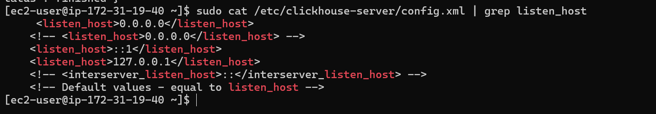
Step-9: Verify the installation
sudo systemctl status clickhouse-server.service
sudo systemctl status zookeeper.service
sudo journalctl -u clickhouse-server.service -f
sudo journalctl -u zookeeper.service -f
Step-10: Run Clickhouse migrations
- Get and extract the latest release of SigNoz Schema Migrator
curl -L https://github.com/SigNoz/signoz-otel-collector/releases/latest/download/signoz-schema-migrator_linux_$(uname -m | sed 's/x86_64/amd64/g' | sed 's/aarch64/arm64/g').tar.gz -o signoz-schema-migrator.tar.gz
tar -xzf signoz-schema-migrator.tar.gz
- Run the migrations
./signoz-schema-migrator_linux_$(uname -m | sed 's/x86_64/amd64/g' | sed 's/aarch64/arm64/g')/bin/signoz-schema-migrator sync --dsn="tcp://localhost:9000?password=<your clickhouse password>" --replication=true --up=
./signoz-schema-migrator_linux_$(uname -m | sed 's/x86_64/amd64/g' | sed 's/aarch64/arm64/g')/bin/signoz-schema-migrator async --dsn="tcp://localhost:9000?password= <your clickhouse password >" --replication=true --up=

To Check the usage of Clickhouse VM
clickhouse-client --host 172.31.19.40 --port 9000 --user default --password pranavpp37@
Query:
SELECT
database,
table,
formatReadableSize(sum(bytes)) AS size
FROM system.parts
WHERE active
GROUP BY database, table
ORDER BY sum(bytes) DESC;
Total Storage
SELECT formatReadableSize(sum(bytes))
FROM system.parts
WHERE active;

CLICKHOUSE COMPRESSION PROOF
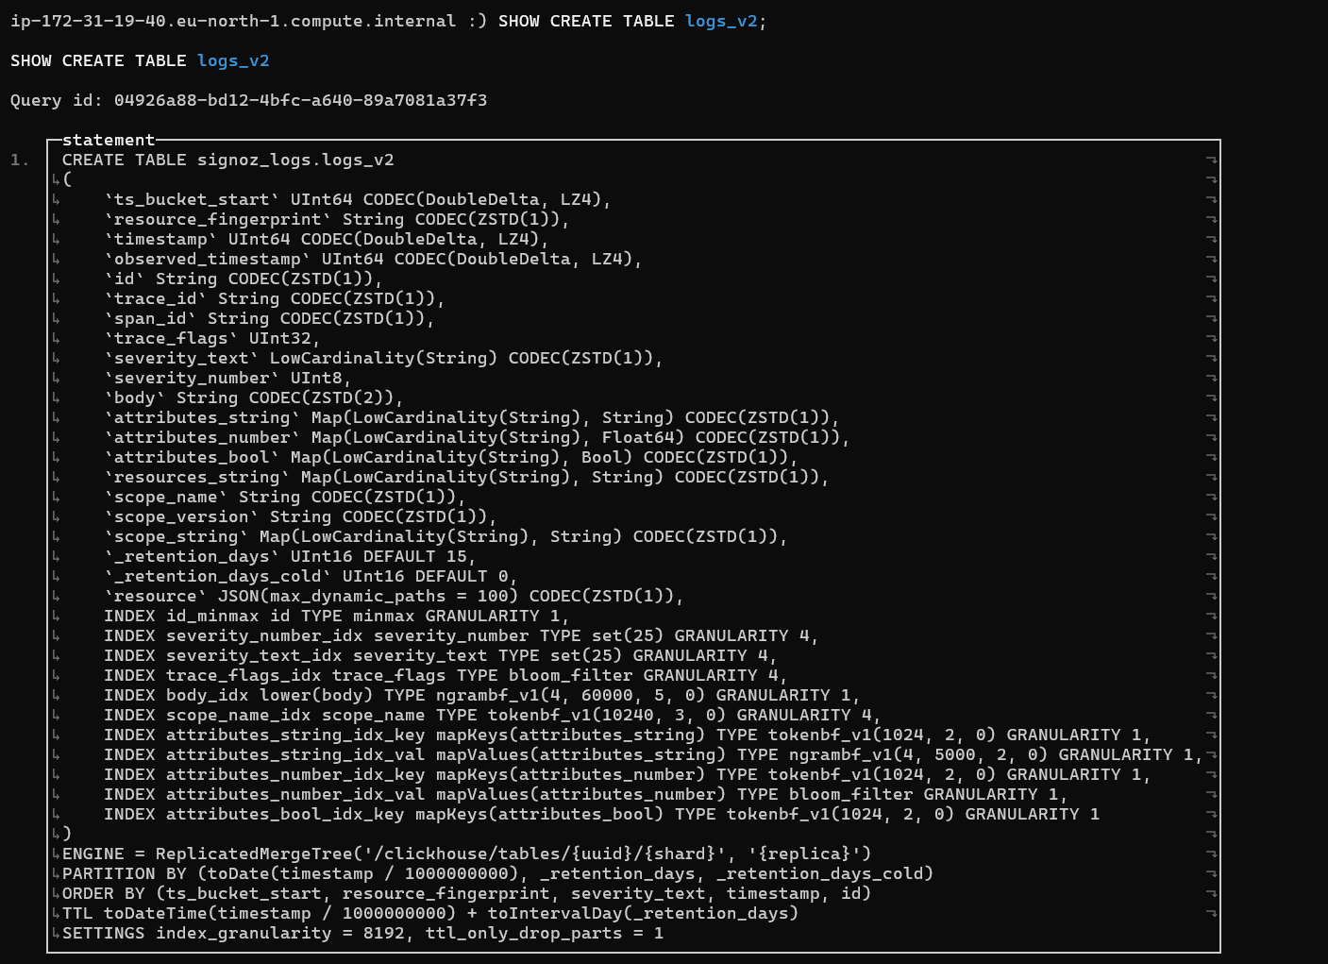
Run Query:
SELECT
table,
formatReadableSize(sum(data_compressed_bytes)) AS compressed,
formatReadableSize(sum(data_uncompressed_bytes)) AS uncompressed,
round(sum(data_uncompressed_bytes) / sum(data_compressed_bytes), 2) AS compression_ratio
FROM system.parts
WHERE database = 'signoz_logs'
AND active
GROUP BY table
ORDER BY sum(data_compressed_bytes) DESC;
